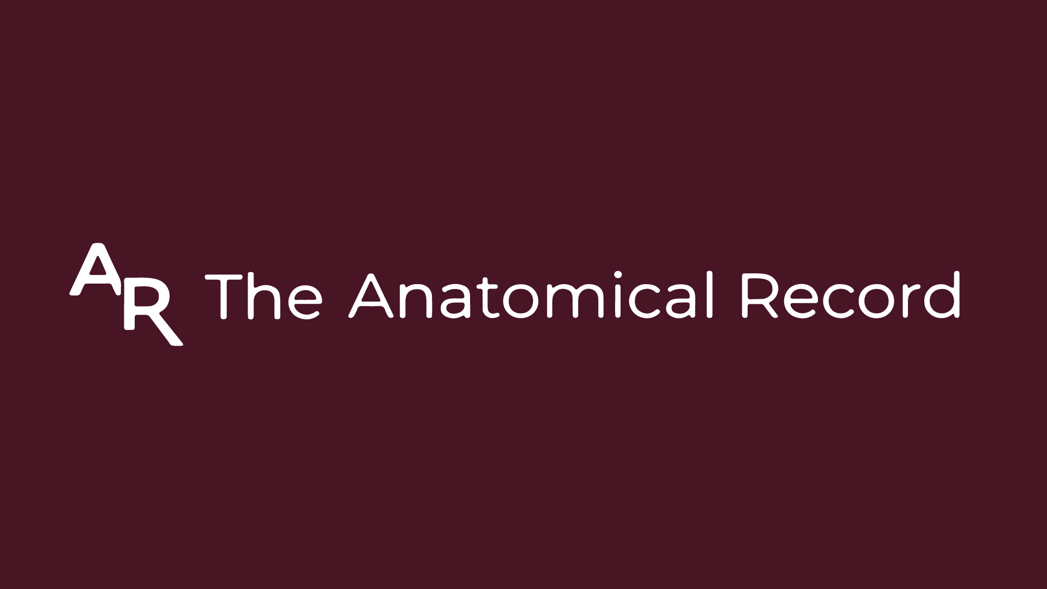
ANATOMICAL RECORD TRAVEL GRANT

The symposium “Advances on the histology of the mineralised tissues of vertebrates” sponsored by Anatomical Records, is offering travel grants for delegates participating in the symposium, providing US$1000 to five postgraduate students (including postdoctoral fellows) to attend the upcoming IPC7 meeting.
The funds may be used toward registration, accommodation, or airfare expenses and will be reimbursed to the recipients after the conference.

APPLICANT DETAILS
Name:
Surname:
Email:
Address:
Educational Level:
Current Institution:
Please submit the following information:
- Motivation letter (max 300 words): please provide a motivation as to why you should be considered for the conference travel grant.
- Curriculum vitae: maximum 5 pages.
- Title and abstract of your presentation.
Application should be email to carmen.nacarino@icp.cat, G.montoya.sanhueza@gmail.com or m.eugenia.pereyra@gmail.com by 1st May 2026.
Subject line: AR Travel Grant

